

Heap Memory Optimisation for a Semantic Information Retrieval System

1.Summary
This report documents a comprehensive heap memory optimisation initiative for a semantic information retrieval system handling over 131 million tokens across 898,769 documents. The optimisation achieved a 54% reduction in RAM utilisation (from 26GB to 12GB) while simultaneously improving query response time by 97% (from 300ms to 10ms) and increasing throughput from 250 to 560 transactions per second.
1. Problem Statement
The semantic IR system faced critical scalability constraints that prevented system expansion and threatened operational stability:
- Inability to add new training datasets due to memory exhaustion - System encountered Out Of Memory (OOM) errors when attempting to expand the knowledge base
- Excessive memory footprint - Training weights consumed 25-26GB RAM, leaving insufficient resources for concurrent operations
- Dataset scale - System processed 131,467,363 total tokens from 898,769 documents (equivalent to 224,853 book pages)
- Infrastructure requirements - Necessitated expensive hardware upgrades (additional RAM and processors)

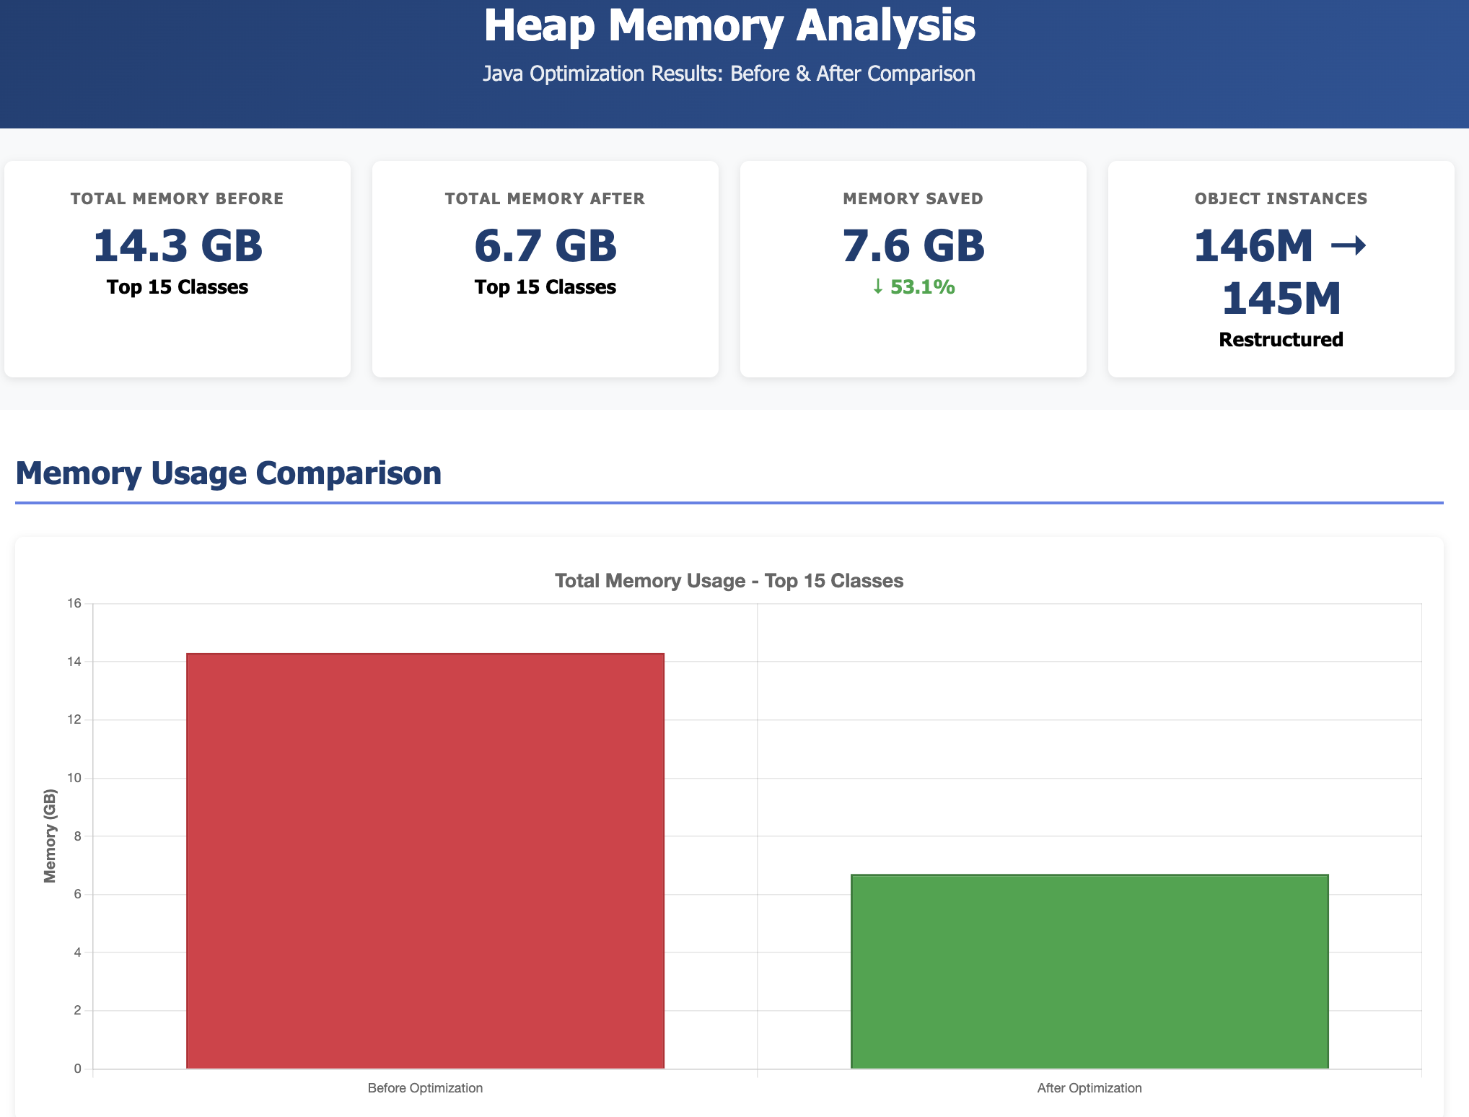

Fig. 1: Heap Memory Analysis Summary(Before and After Optimization)

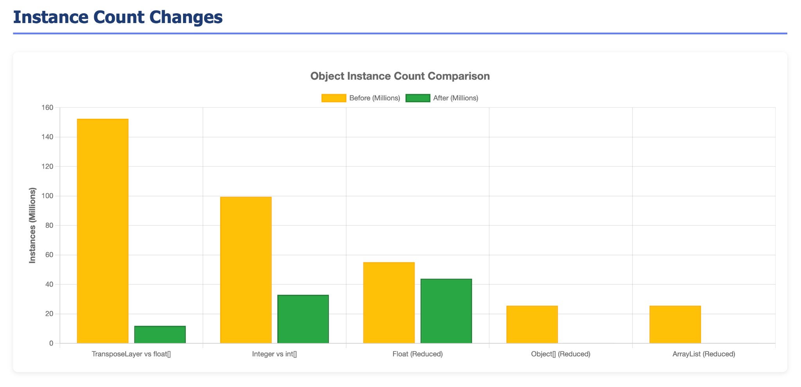
Fig. 1a: Object instances count Analysis Summary(Before and After Optimisation)

2. System Architecture
2.1 Data Structure Overview

The semantic IR system utilizes three primary data structures for token encoding, context management, and pattern recognition:
Component | Purpose | Data Scale
Token Encoding | Vector representations of vocabulary terms | 2,494,624 words
Token Context | Page-level token occurrence and weighting | 898,769 documents (224,853 pages)
Transpose Layer | Pattern recognition and semantic relationships | 131,467,363 recognized patterns
Table 1: Data-structure overview
3. Optimization Strategy
The optimization approach focused on eliminating object overhead through primitive type migration, reducing memory allocation through array-based structures, and minimizing garbage collection pressure through efficient data organization.
3.1 Core Optimization Principles
- Primitive Types Over Boxed Primitives - Eliminated object headers and autoboxing overhead by using primitive data types (float, int) instead of wrapper classes (Float, Integer)
- Array-Based Data Structures - Replaced collection-based implementations with primitive arrays to achieve contiguous memory allocation and reduce per-element overhead
- Object Association Reduction - Flattened data structures to eliminate nested objects, removing unnecessary pointer indirection and object headers
- Third-Party Dependency Minimization - Eliminated external dependencies where custom implementations could provide equivalent functionality with lower memory overhead
- Garbage Collection Optimization - Ensured method conciseness to enable efficient GC of temporary objects
- Conducted production heap analysis using JCMD and JPS.
- Refactored transpose and token context layers to minimise heap fragmentation.

4. Implementation Details

4.1 Token Encoding Optimization

Transformation: Map<String, Float> → Map<String, float[]>
Impact: Physical Memory reduced from 537.23 MB to 484.5 MB (9.8% reduction)
This optimization maintained the Map structure for efficient key-based lookup while ensuring float arrays use primitive storage, eliminating Float wrapper overhead for the 2,494,624 vocabulary terms.
4.2 Token Context Optimisation
Transformation: Map<Float, List<TokenContext>> → Map<Float, float[][]>
Previous Structure: TokenContext{ int pageIndex, List<Float> pageWeights }
Impact: Physical Memory reduced from 934.09 MB to 604.43 MB (35.3% reduction)
By replacing List<TokenContext> with float[][], the implementation eliminated object headers for each TokenContext instance and List wrapper. The two-dimensional array structure maintains page index as the first dimension and page weights as the second, preserving data relationships while achieving significant memory savings across 898,769 documents.
4.3 Transpose Layer Optimisation

Transformation: Map<Float, List<List<TokenTranspose>>> → Map<Float, float[][]>
Previous Structure: TokenTranspose{ int level, float source }
Impact: Physical Memory reduced from 2086.54 MB to 1201.01 MB (42.4% reduction)
This transformation yielded the largest absolute memory savings. The nested List<List<TokenTranspose>> structure created multiple object allocation points. By converting to float[][], the implementation eliminated object headers for 131+ million token patterns while preserving hierarchical relationships via array dimensions.
5. Memory Analysis Results
5.1 Comparative Memory Footprint
Memory profiling using Java Command Line (jcmd) and Java Process Status (jps) tools revealed significant reductions across all major object types. The following analysis presents the top 10 memory consumers before and after optimization.

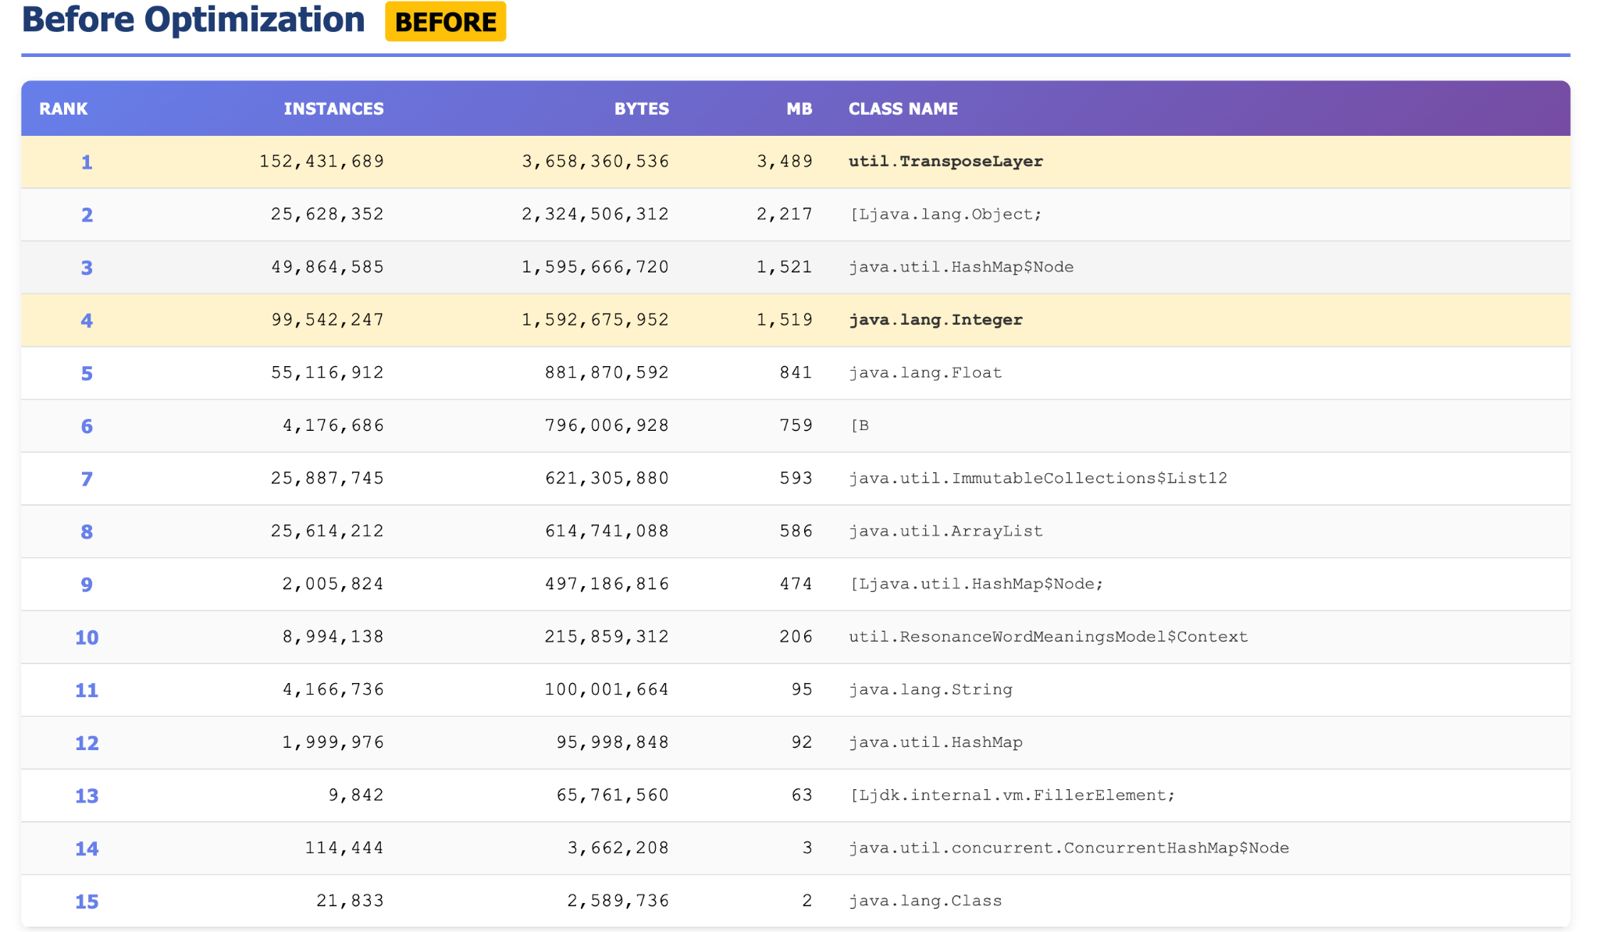
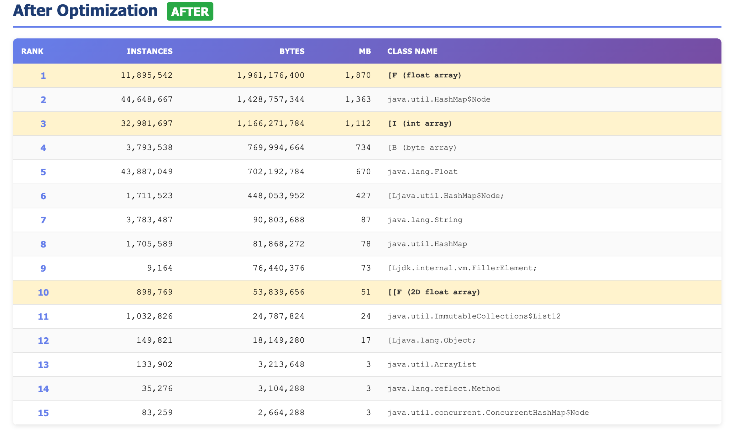

Fig. 2: Summarised Heap Memory Analysis Result(Top 15)

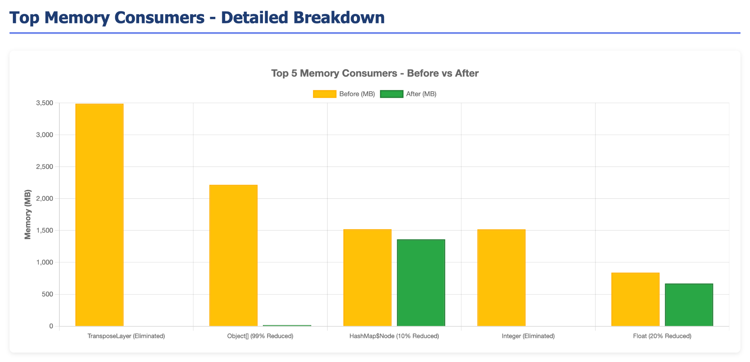
Fig. 2a: Top Memory Summary
Key Observations:
- Complete elimination of TransposeLayer custom objects (3.66 GB reduction)
- Substantial reduction in boxed Integer instances (1.59 GB eliminated)
- Introduction of primitive float arrays (1.96 GB) and int arrays (1.17 GB) as primary data structures
- 20.4% reduction in Float objects still present for Map keys
6. Performance Results
6.1 Phsical Memory Utilization on Disk
Component | Before (MB) | After (MB) | Reduction
Token Encoding | 537.23 | 484.5 | 9.8%
Token Context | 934.09 | 604.43 | 35.3%
Transpose Layer | 2086.54 | 1201.01 | 42.4%
Total System RAM | 26 GB | 12 GB | 53.8%
6.2 Query Performance

Metric | Before | After | Improvement
Query Response Time | 300 ms | 10 ms | 96.7%
Throughput (TPS) | 250 | 560 | 124%
System RAM Required | 26 GB | 12 GB | 53.8%
The performance improvements resulted from multiple factors:
– Reduced memory allocation/deallocation overhead,
– improved CPU cache utilization through contiguous array storage,
– Decreased garbage collection frequency, and elimination of autoboxing operations during data access.

7. Technical Methodology
7.1 Memory Profiling Tools
The optimisation process utilised Java's diagnostic command-line tools for production heap memory investigation:
- jps (Java Process Status): Identified active Java process IDs running in the production environment
- jcmd (Java Command): Executed diagnostic commands to generate heap histograms showing object instance counts and memory consumption by class
7.2 Validation Approach

Post-optimization validation encompassed:
- Functional correctness: Verified semantic search results remained identical to pre-optimization outputs
- Performance benchmarking: Measured query latency and throughput under production-equivalent load on 32GB RAM system
- Memory profiling: Captured heap histograms before and after optimization for comparative analysis
- Stability testing: Executed extended runtime tests to verify garbage collection behavior and absence of memory leaks

8. Business Impact
8.1 Immediate Benefits
- System Expansion Capability: Eliminated memory constraints preventing addition of new training datasets, enabling knowledge base growth
- Infrastructure Cost Reduction: Halved RAM requirements obviate need for expensive hardware upgrades, reducing cloud hosting expenses
- User Experience Enhancement: 97% reduction in query latency (300ms to 10ms) provides near-instantaneous search results
- System Capacity: 124% throughput improvement (250 to 560 TPS) supports concurrent user growth without infrastructure scaling
8.2 Strategic Advantages
- Mobile Deployment Viability: 12GB memory footprint makes offline mobile deployment feasible on devices with 3-4GB RAM in future releases, enabling semantic document search without internet connectivity
- Competitive Positioning: Sub-millisecond query latency provides significant performance advantage over competing semantic search solutions
- Operational Resilience: Reduced memory pressure improves system stability and reduces Out Of Memory error risk during peak usage

9. Technical Insights and Best Practices

The optimization initiative yielded several critical insights applicable to high-performance Java systems:
9.1 Memory Management Principles
- Primitive Type Preference: Always prefer primitive data types (int, float, double) over their boxed equivalents (Integer, Float, Double). Each boxed primitive incurs 16 bytes of object header overhead plus 8 bytes for the value, compared to 4-8 bytes for primitives. At scale (millions of instances), this overhead becomes prohibitive.
- Array-Based Storage: Utilize primitive arrays or specialized collection APIs when working with large datasets. Collections like ArrayList<Float> create object overhead for each element; primitive float[] arrays provide contiguous memory allocation with minimal overhead.
- Dependency Minimization: Critically evaluate third-party dependencies. Custom implementations tailored to specific use cases often provide equivalent functionality with dramatically lower memory footprint. Each additional dependency introduces transitive dependencies and object allocation overhead.
- Garbage Collection Optimization: Maintain concise method implementations to facilitate efficient garbage collection. Long-running methods prevent temporary object cleanup, increasing heap pressure. Break complex operations into smaller methods to enable incremental GC.
9.2 Data Structure Design
- Object Association Minimization: Flatten nested object hierarchies wherever possible. Each level of object nesting introduces pointer indirection (8 bytes per reference on 64-bit JVM) plus object header overhead. Multi-dimensional primitive arrays often provide equivalent functionality with significantly reduced memory consumption.
- Composite Data Encoding: When objects contain only primitive fields, consider encoding multiple properties in array indices rather than creating object instances. For example, TokenContext{int pageIndex, List<Float> weights} can be represented as float[][] where the first dimension encodes pageIndex and the second encodes weights.
9.3 Profiling and Measurement
- Production Profiling: Utilize jcmd and jps for production environment analysis. These lightweight tools provide heap histograms without requiring heap dump generation, enabling diagnosis without service disruption.
- Iterative Optimization: Target the largest memory consumers first. The Transpose Layer optimization (42.4% reduction) yielded greater absolute savings than Token Encoding optimization (9.8% reduction) despite requiring similar implementation effort.
9.4 Java Platform Capabilities

This optimization demonstrates that Java, when used with careful attention to memory management principles, can achieve performance characteristics comparable to lower-level languages. The 54% memory reduction and 124% throughput improvement were accomplished without algorithmic changes or JVM modifications—solely through data structure optimization.

10. Conclusion
The heap memory optimization initiative successfully addressed critical scalability constraints in the semantic information retrieval system, achieving 54% memory reduction (26GB to 12GB) while simultaneously improving query performance by 97% (300ms to 10ms latency) and throughput by 124% (250 to 560 TPS).
The optimization approach—prioritizing primitive types, utilizing array-based storage, minimizing object associations, and eliminating unnecessary dependencies—provides a replicable framework for memory optimization in large-scale Java systems. These principles are particularly relevant for applications handling millions of objects where object overhead accumulates to significant memory consumption.
The results validate that Java, with proper memory management practices, can deliver high-performance characteristics suitable for resource-constrained environments including mobile deployment. The system now processes 131+ million tokens across 898,769 documents with half the previous memory footprint while providing substantially improved responsiveness.
Future work will focus on leveraging the reduced memory footprint to expand the training dataset, implement mobile deployment for offline document search, and apply similar optimization principles to additional system components.
Appendix A: Complete Heap Analysis Data

PROD[Before Optimization]

num #instances #bytes class name (module)
-------------------------------------------------------
1: 152431689 3658360536 util.TransposeLayer
2: 25628352 2324506312 [Ljava.lang.Object; (java.base@21.0.9)
3: 49864585 1595666720 java.util.HashMap$Node (java.base@21.0.9)
4: 99542247 1592675952 java.lang.Integer (java.base@21.0.9)
5: 55116912 881870592 java.lang.Float (java.base@21.0.9)
6: 4176686 796006928 [B (java.base@21.0.9)
7: 25887745 621305880 java.util.ImmutableCollections$List12 (java.base@21.0.9)
8: 25614212 614741088 java.util.ArrayList (java.base@21.0.9)
9: 2005824 497186816 [Ljava.util.HashMap$Node; (java.base@21.0.9)
10: 8994138 215859312 util.ResonanceWordMeaningsModel$Context
11: 4166736 100001664 java.lang.String (java.base@21.0.9)
12: 1999976 95998848 java.util.HashMap (java.base@21.0.9)
13: 9842 65761560 [Ljdk.internal.vm.FillerElement; (java.base@21.0.9)
14: 114444 3662208 java.util.concurrent.ConcurrentHashMap$Node (java.base@21.0.9)
15: 21833 2589736 java.lang.Class (java.base@21.0.9)

[AFTER_OPTIMIZATION]

num #instances #bytes class name (module)
-------------------------------------------------------
1: 11895542 1961176400 [F (java.base@21.0.10)
2: 44648667 1428757344 java.util.HashMap$Node (java.base@21.0.10)
3: 32981697 1166271784 [I (java.base@21.0.10)
4: 3793538 769994664 [B (java.base@21.0.10)
5: 43887049 702192784 java.lang.Float (java.base@21.0.10)
6: 1711523 448053952 [Ljava.util.HashMap$Node; (java.base@21.0.10)
7: 3783487 90803688 java.lang.String (java.base@21.0.10)
8: 1705589 81868272 java.util.HashMap (java.base@21.0.10)
9: 9164 76440376 [Ljdk.internal.vm.FillerElement; (java.base@21.0.10)
10: 898769 53839656 [[F (java.base@21.0.10)
11: 1032826 24787824 java.util.ImmutableCollections$List12 (java.base@21.0.10)
12: 149821 18149280 [Ljava.lang.Object; (java.base@21.0.10)
13: 133902 3213648 java.util.ArrayList (java.base@21.0.10)
14: 35276 3104288 java.lang.reflect.Method (java.base@21.0.10)
15: 83259 2664288 java.util.concurrent.ConcurrentHashMap$Node (java.base@21.0.10)
16: 20669 2453960 java.lang.Class (java.base@21.0.10)
17: 4945 1684992 [C (java.base@21.0.10)
18: 58401 1401624 java.time.LocalDateTime (java.base@21.0.10)

POST PROD DEPLOYMENT END-USER TESTS

